'Between the Sun and the Sky' Price List

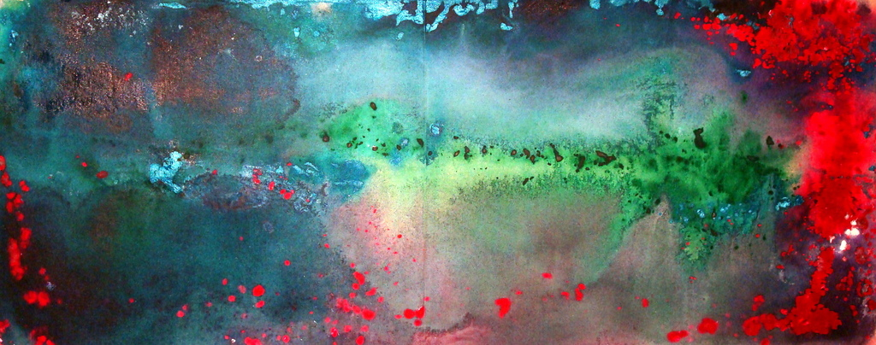

Title: Cluster
Year Created: 2016
Medium: Acrylic on canvas
Dimensions: 17” x 46”
Price: $800.00

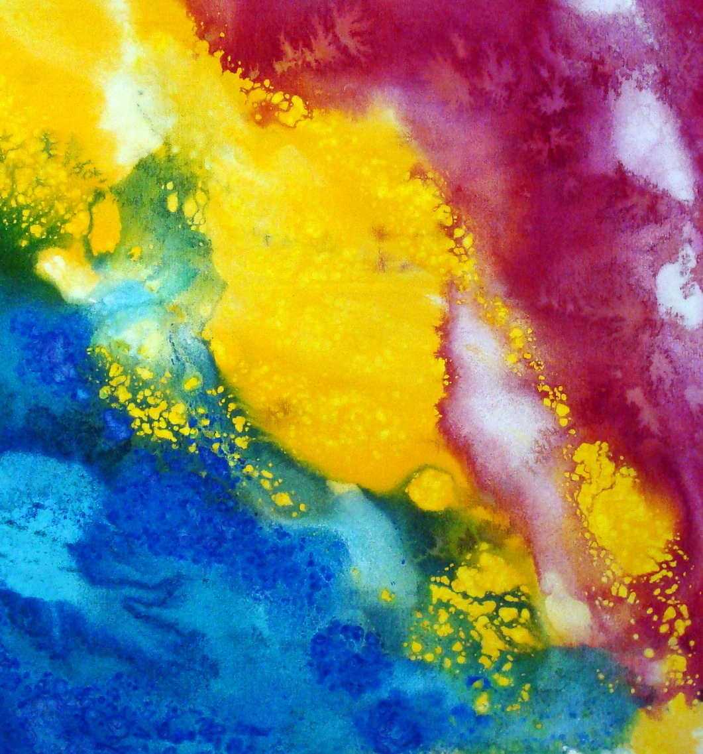

Title: Blue Territory
Year Created: 2018
Medium: Acrylic on canvas
Dimensions: 20” x 18”
Price: $360.00

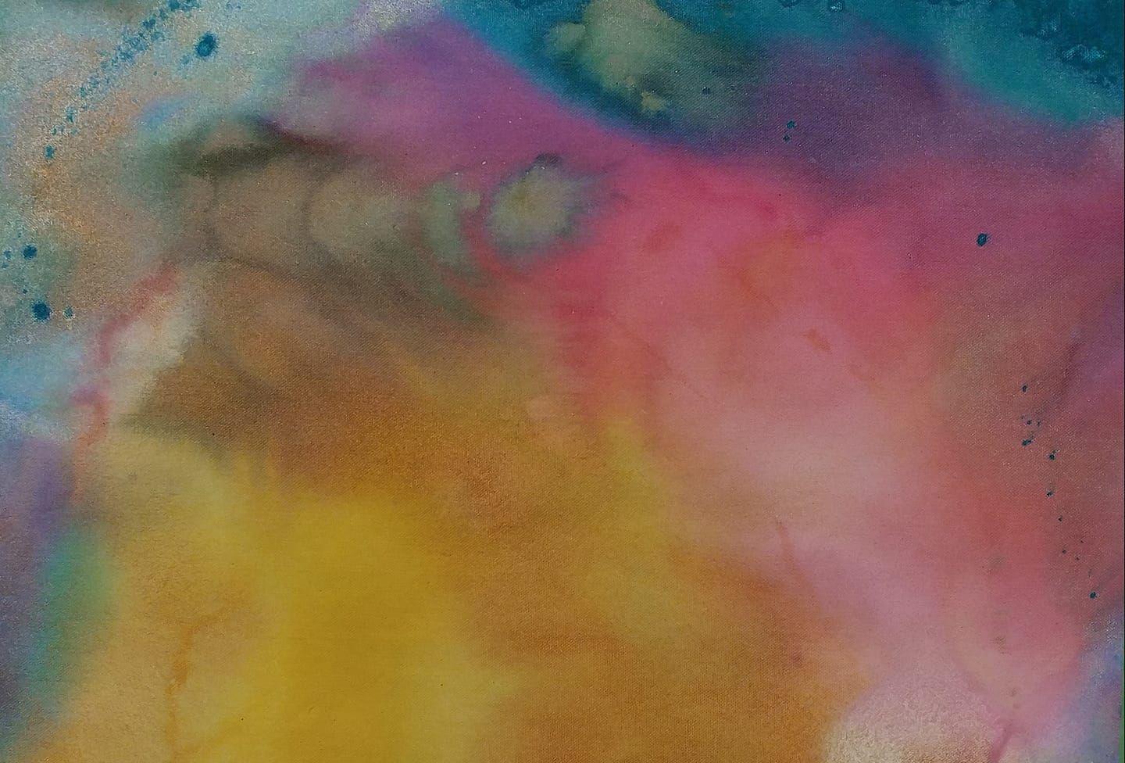
Title: Glitter Mirror
Year Created: 2018
Medium: Acrylic on canvas
Dimensions: 14.5” x 21.5”
Price: $300.00

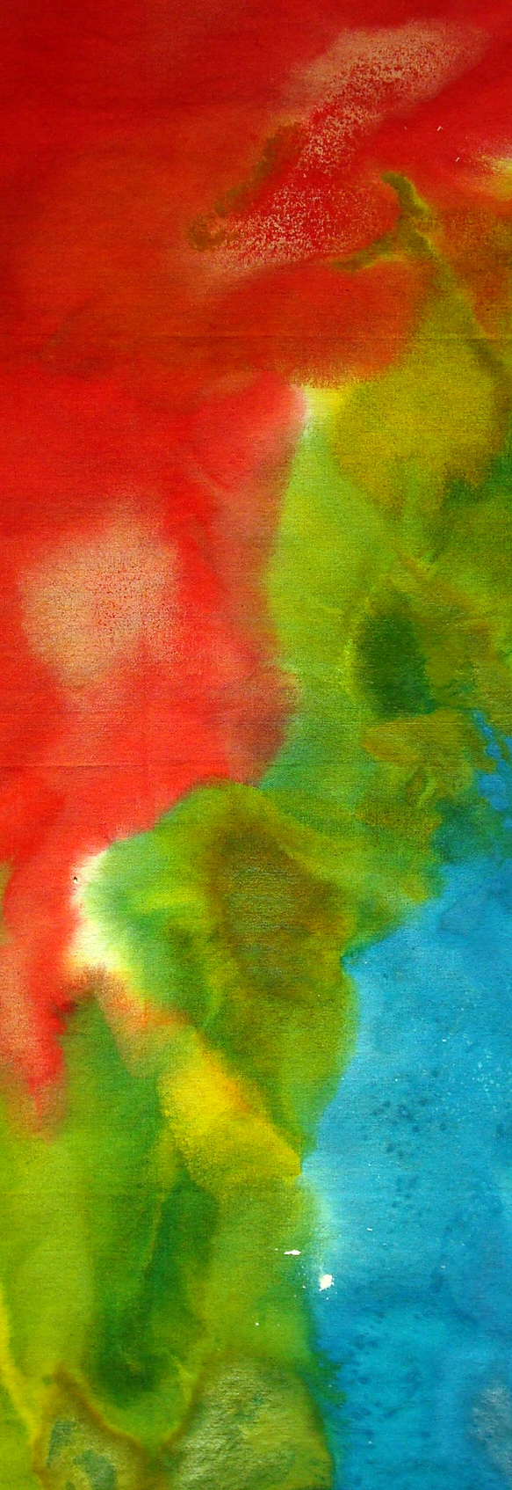
Title: Emotional Tremor
Year Created: 2017
Medium: Acrylic on canvas
Dimensions: 38” x 12”
Price: $450.00

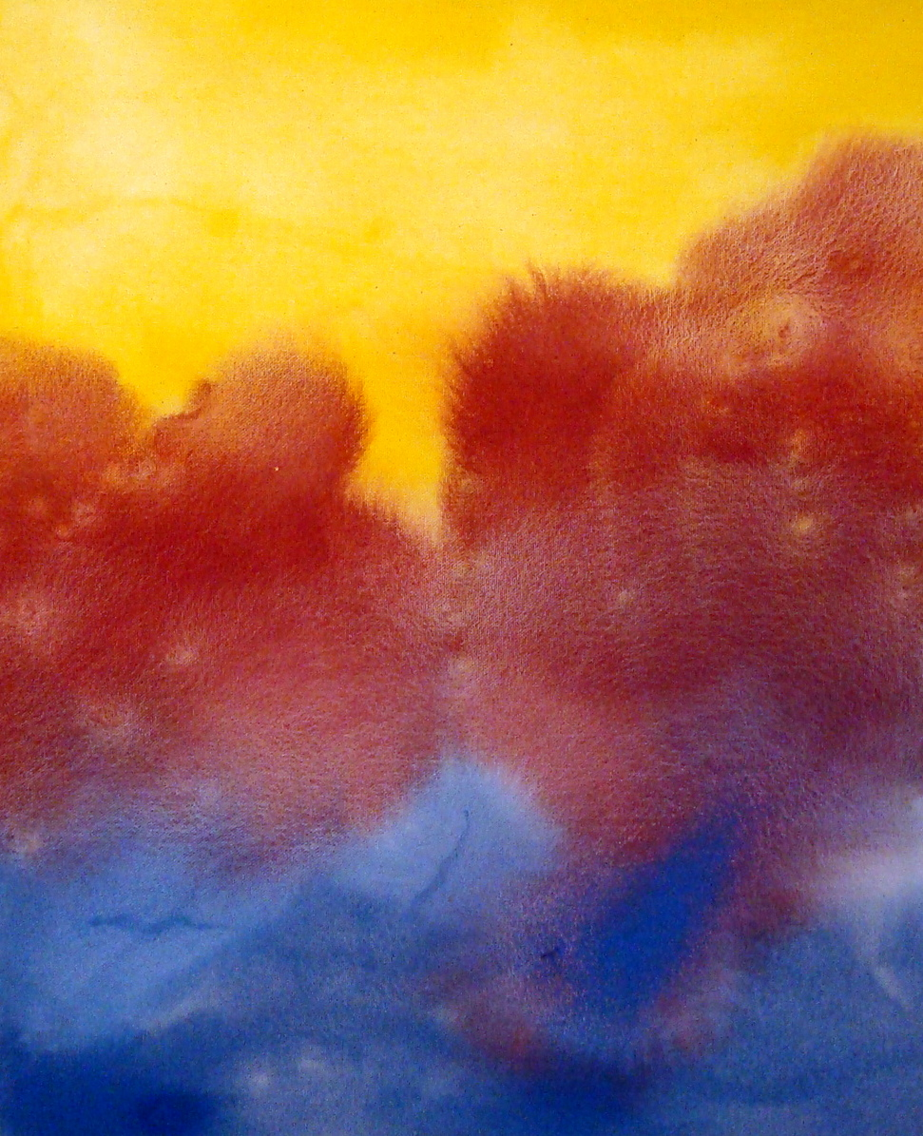
Title: Red Oxide Sky
Year Created: 2018
Medium: Acrylic on canvas
Dimensions: 19” x 15.5”
Price: $300.00
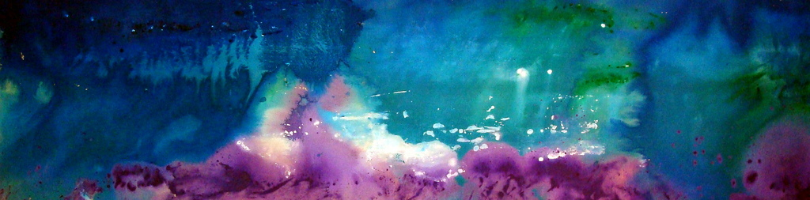

Title: Lagoon
Year Created: 2016
Medium: Acrylic on canvas
Dimensions: 26” x 104”
Price: $2,700.00

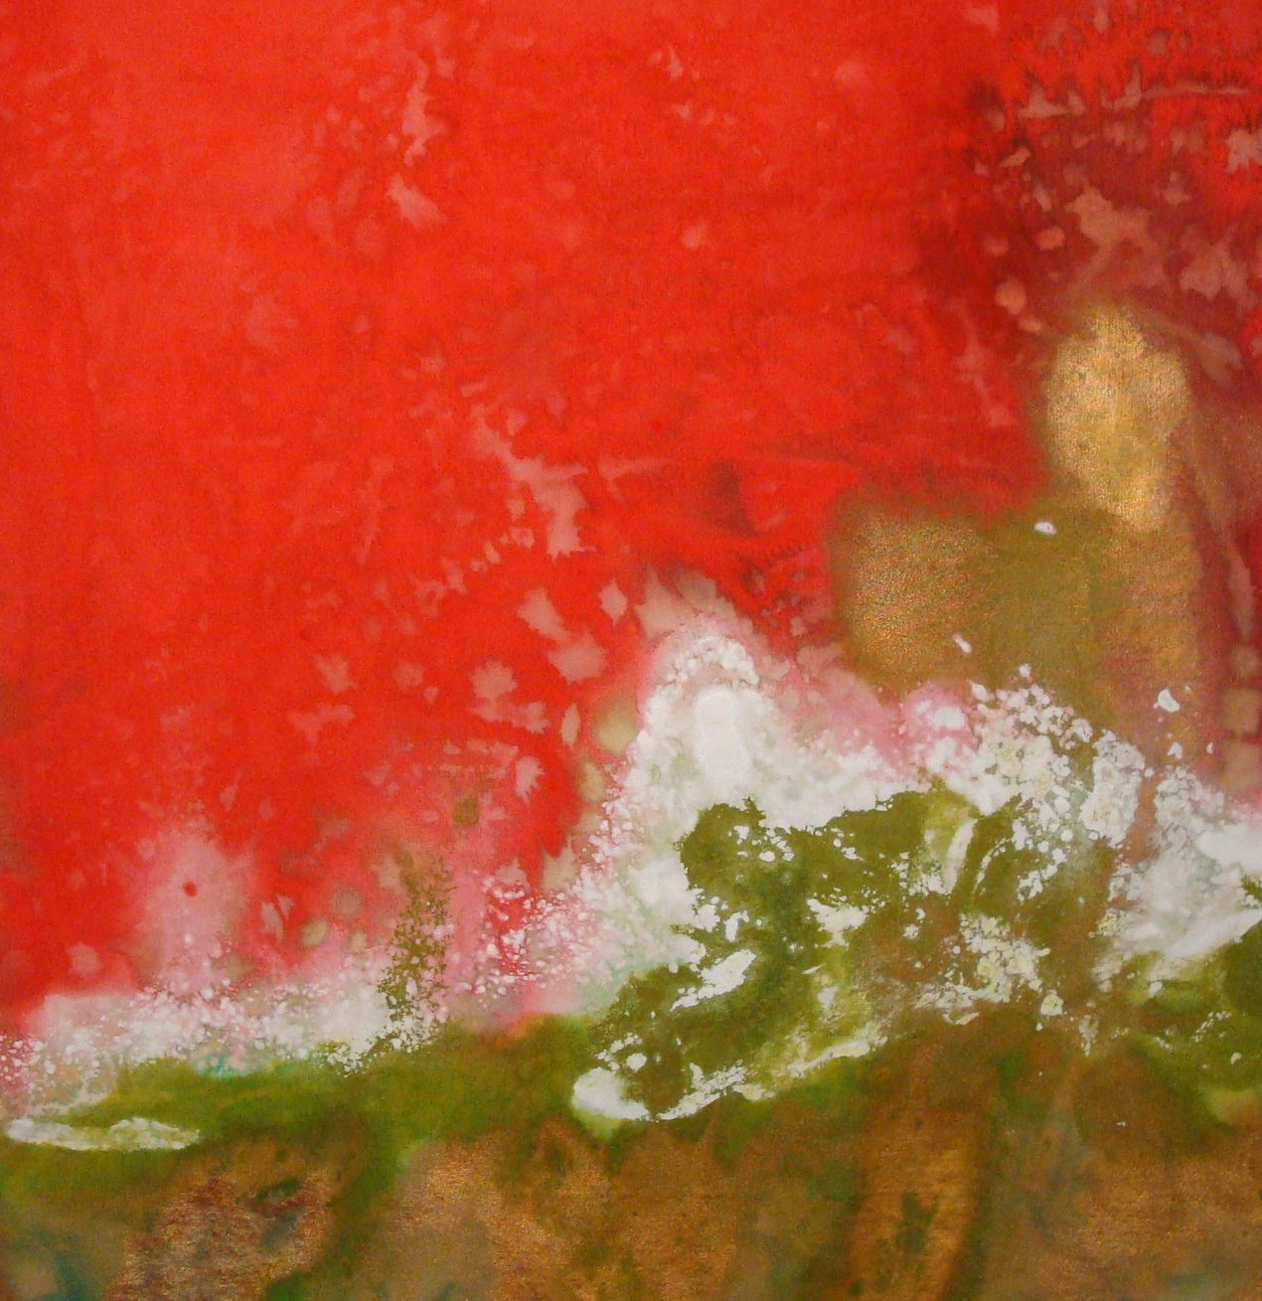
Title: Crumbling Palace
Year Created: 2018
Medium: Acrylic on canvas
Dimensions: 30” x 30”
Price: $900.00

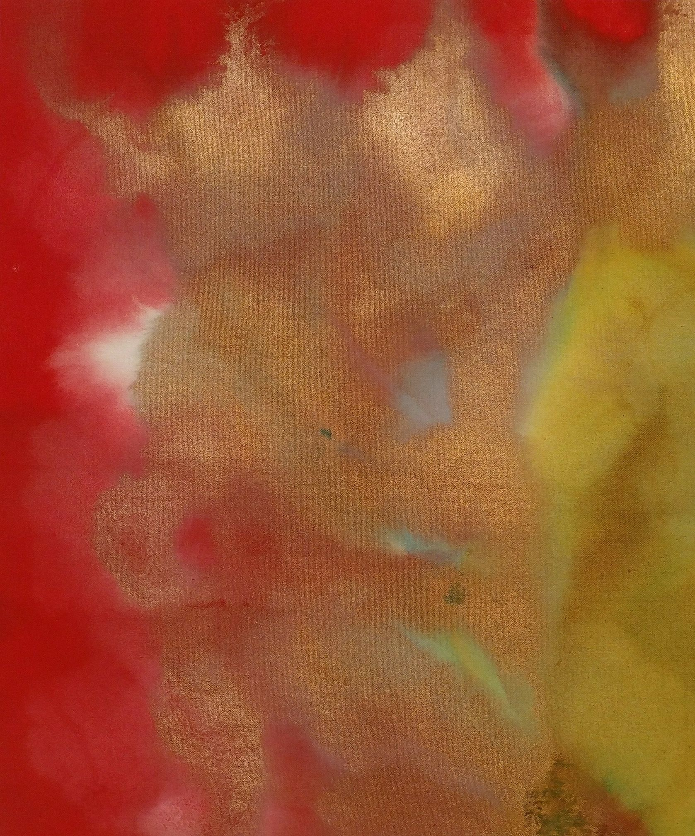
Title: Oblivescence
Year Created: 2018
Medium: Acrylic on canvas
Dimensions: 20.25” x 17”
Price: $350.00

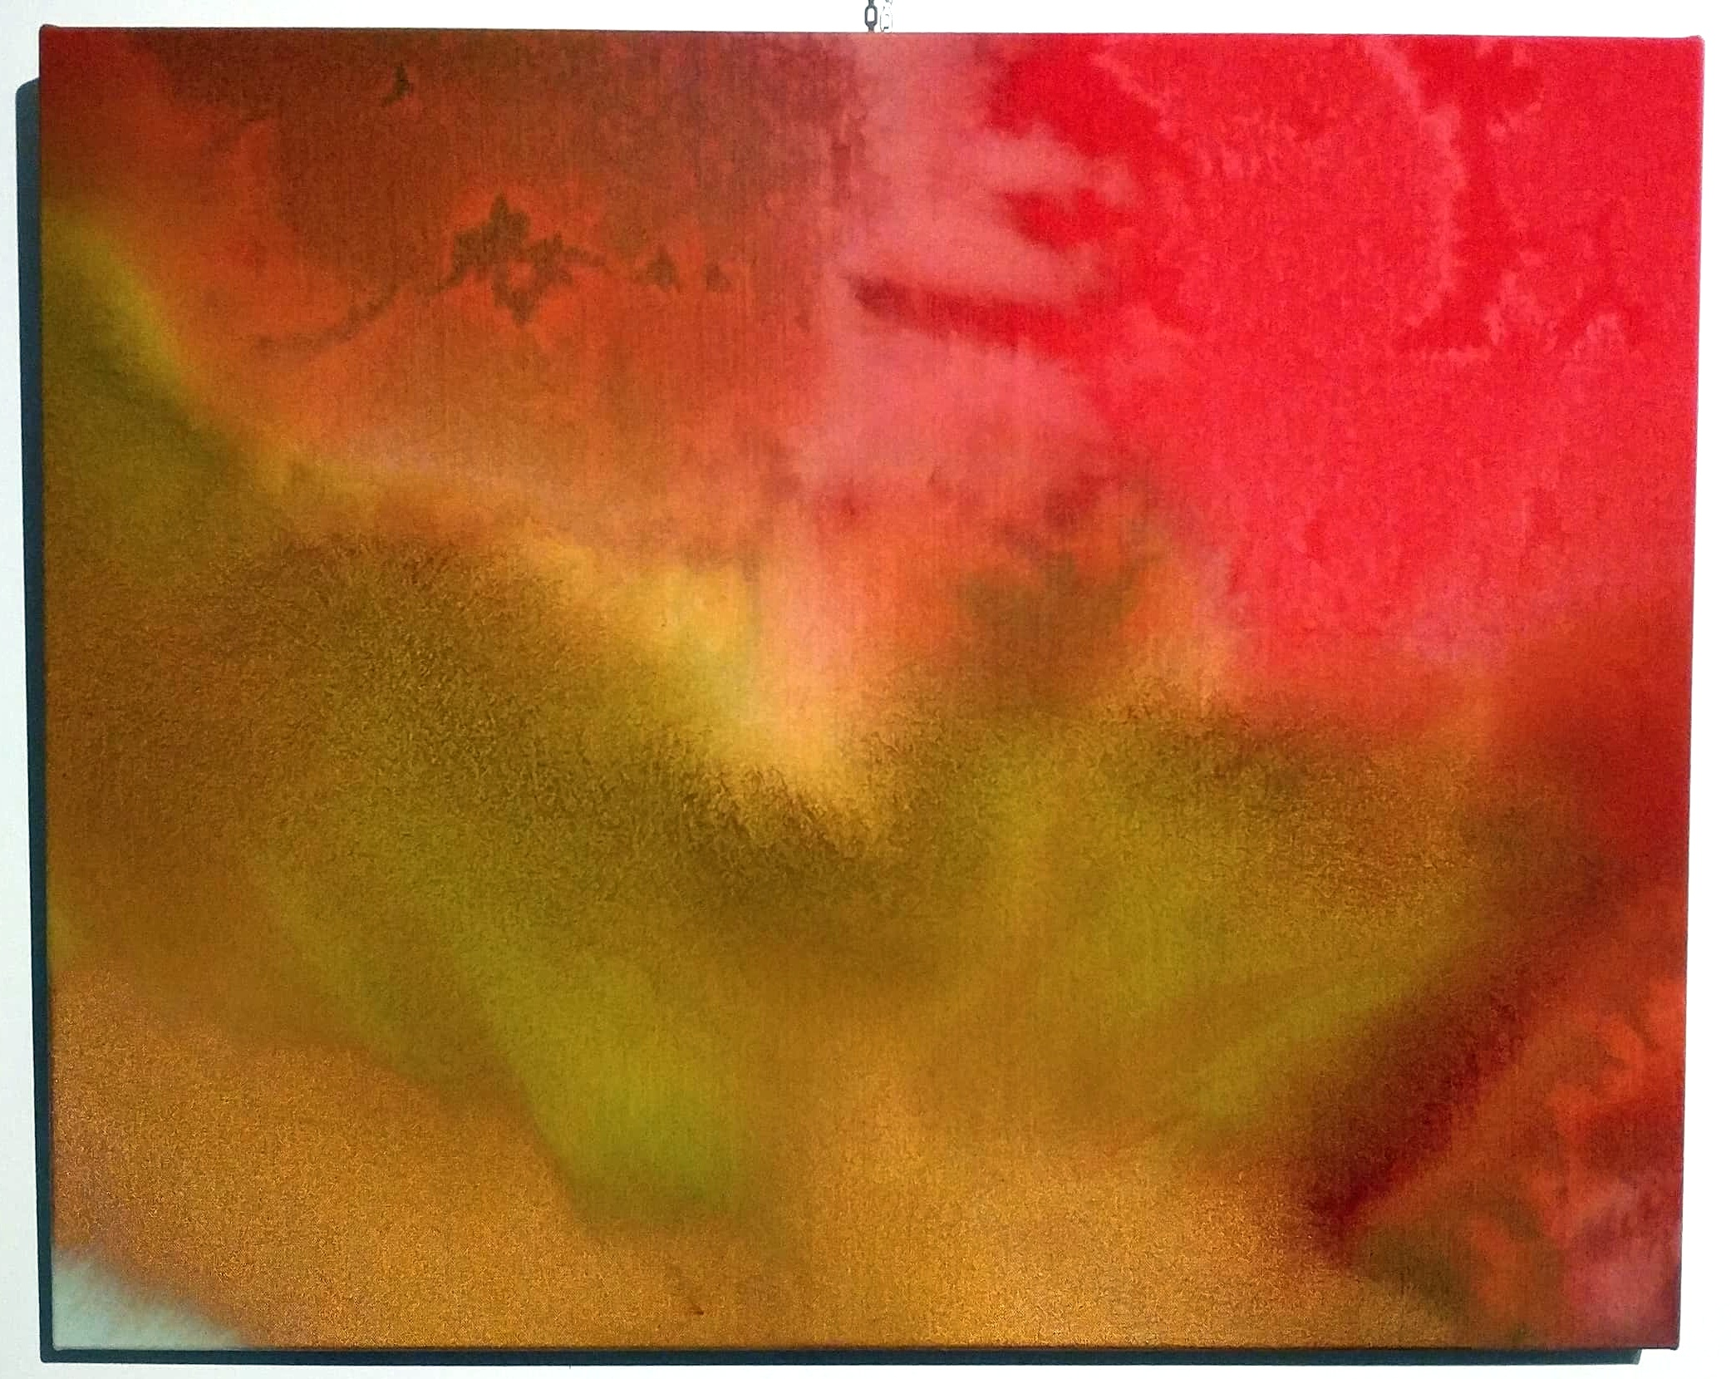
Title: Pockets of Slumber
Year Created: 2018
Medium: Acrylic on canvas
Dimensions: 24” x 30”
Price: $720.00

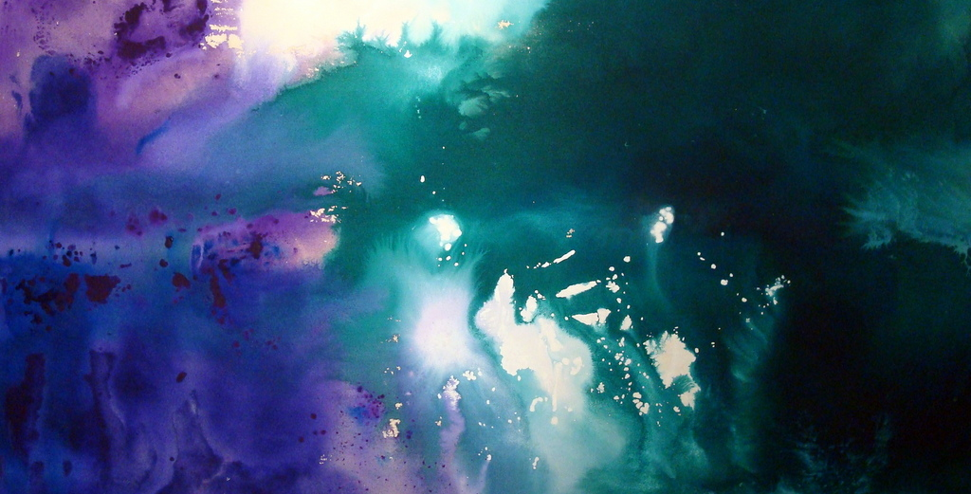
Title: Wonder
Year Created: 2016
Medium: Acrylic on canvas
Dimensions: 32.25” x 66.25”
Price: $2,100.00

